PUBLICATION CHARGE CERTIFICATION
Hydrological Research Letters

Valid April 15, 2020

The authors or their institution are requested to help support the costs of publication which should be regarded as an essential and proper part of the research budget. The costs cover editorial operation, English correction, uploading, and other works relevant to preparation of a paper for printing and its inclusion in international databases. We cannot publish the accepted manuscript unless the publication charge is paid.

Editor-in-Chief

Author(s) are requested to fill this form and submit it to the Production Department (hrl@nacos.com) upon proofreading.

Manuscript number  (e.g. HRL19-00001) | HRL
Corresponding Author Name

Signature of Corresponding Author (PRINT NAME) Date

Order of reprints

Please check the applicable item on the checkbox.
If you want the reprints, please choose the desired number of copies.
☐ Choose an item. copies with covers.
☐ We (I) would like to leave Choose an item. copies from my reprints order and ask to distribute them at meetings, symposium, and workshops.
※ See the next page for reprints price list
※ Order only in lots of 50
☐ We (I) do not need reprints.

Bill to: (Please fill in Japanese if the recipient is Japanese)

Name
Department
Institution
TEL
FAX
E-mail
Address

(including city, state, zip code, and nation)

Mail reprints to: (Please fill in Japanese if the recipient is Japanese)

Name
Department
Institution
Address

(including city, state, zip code, and nation)

Reprint Price List (tax included)
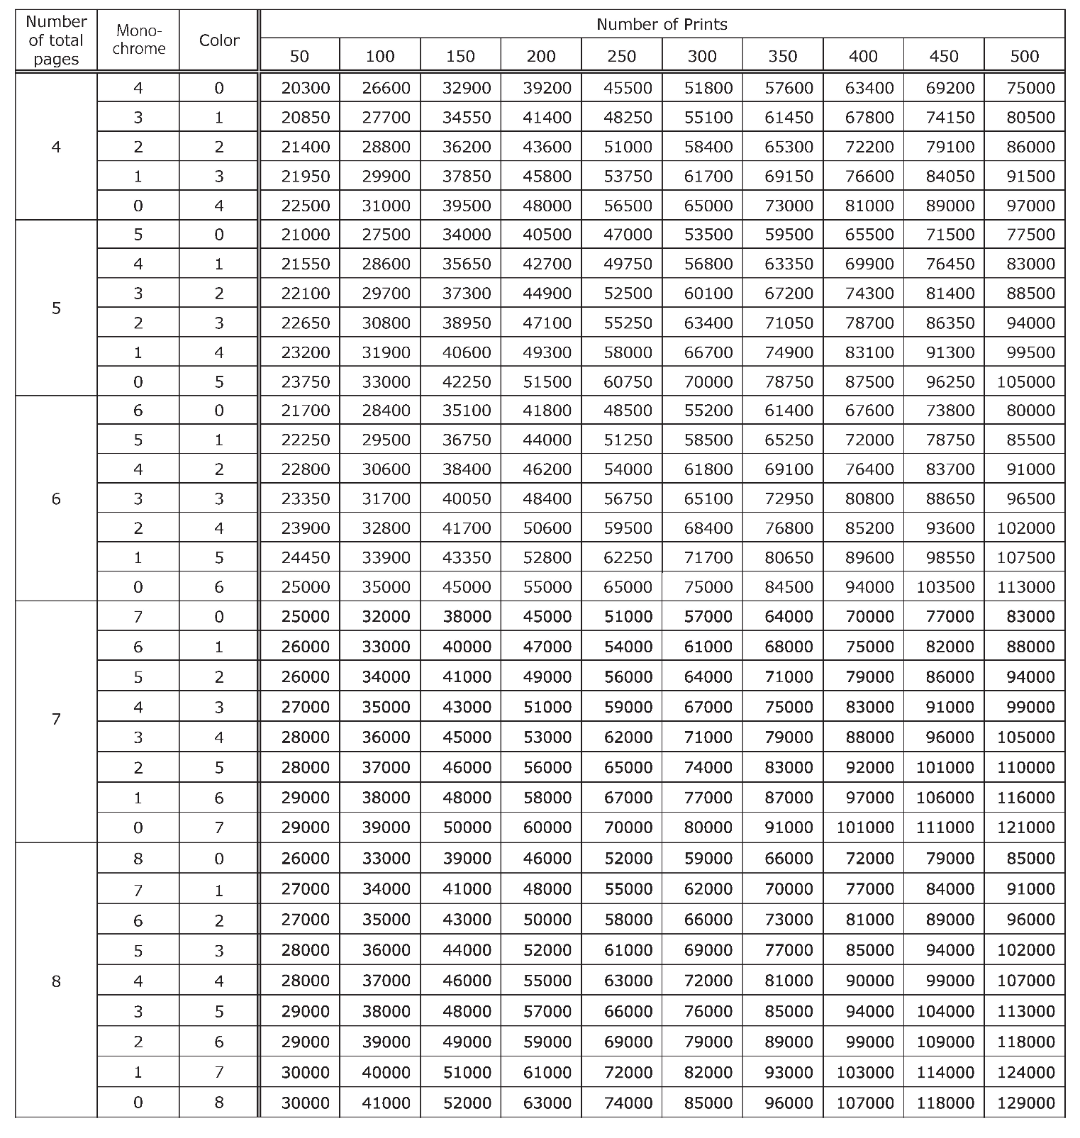
Currency: JPY

Note: Only lots of 50 are available. Shipping fee: 1000 JPY within Japan; 3000 JPY outside Japan.

